Soccer Study Guide
Soccer, better known throughout the world as Futbol, has been played since around 200 B.C. The basic international rules have remained almost unchanged since the turn of the century.
THE GAME: Soccer is players by two teams of up to 11 players each. Each goal counts for 1 point. The game is into 2 halves of 45 minutes each. There are no timeouts. Play is continuous, except when a player is injured. If the ball should go out of bounds, play still is continuous.
FIELD: The playing dimensions of a soccer field, is a little larger than an American Football player field. The minimum is 110 yards long by 70 yards in width. The maximum is 120 yards long by 80 yards in width.
PLAYING THE BALL: A players may use any part of their body to play the ball, with the exception of their hands and arms. He/she may use their feet, head, thighs or chest to control or move the ball.
GOALKEEPER: The goalkeeper may use their hands, feet, head, thighs, or chest to secure or control the ball. They can only use their hands inside the penalty area. They also can use as many steps as they need to release the ball within 6 seconds. The goalkeeper may not use their hands: 1) outside the penalty area; 2) When a ball is played back to them by their own teammates; 3) When a ball is thrown to them by one of their own teammates from the sidelines. The Keeper may play the ball with their feet but cannot collect the ball with their hands. The Keeper may use their hands inside the penalty area when 1) the ball is shot at or deflected to them by any player on either team; 2) When the ball is headed to them by one of their own teammates.
RULES: Fouls and misconduct: Direct free kick: A free kick awarded resulting from a foul. The kick is made with no obstruction. Opponents may use as many players they wish to stand in from on the line of the kick, as long as they are 10 yards away from the ball. The defensive tactic is interpreted as a wall. The kick can be put in play by pass or shot at the goal. These fouls result in a direct free kick. Tripping: Hitting a person from behind and taking their legs out from under them. Holding: Grabbing an opponent’s shirt or arm and not letting go. Use of hands: This can be identified by pushing someone in the back as well as knocking down a ball in flight with your hands. Indirect free kick: A free kick awarded from a foul. The kick is made with no obstruction. Opponents may use as many players they wish to stand in from on the line of the kick, as long as they are 10 yards away from the ball. The kick must touch someone before it can enter the goal.
Throw in: When a ball rolls out of bound on the sides of the field, you must use a throw in to put the ball back in play. It is taken along the touch line (sideline), at the point where the ball went out. The ball must be thrown into play with both hands from behind and overhead. Your feet must be planted on the ground and facing the direction you are throwing.
Corner kick: Ball goes over the end line last touched by a defensive player. Ball is placed on the corner of the playing field. Ball is put into play with a direct free kick. ****note: Ball can go into the goal without touching any player.
Goal Kick: Ball goes over the end line last touched by the offensive player. Ball is placed anywhere on the goal box. Direct free kick. ***No player on the defensive team can be in the penalty area during the goal kick. Anyone from the offensive team can take the kick, even the goalkeeper.
Penalty Kick: A free kick awarded to the offensive team for a foul that would result in direct free kick, inside the penalty area. The kick can be taken by anyone on the offensive team, 12 yards from the goal with no obstruction. The goal keeper must stay on the line until the whistle blows. The offensive player has one touch to try to score, it is a live ball. If the ball is touched and saved by the goalkeeper, it is live and anyone can retrieve the ball. If the ball hits the crossbar or post, the shooter is the only player that cannot touch the ball.
Kickoff: Method of putting the ball in play at the beginning of each half and after a goal is scored. All players must be on their defensive half of the field. The defensive team players can align themselves any way they wish, as long as they are outside the center circle. The offensive team must have 2 players by the ball. The rest of the offensive team, can position themselves anyway they wish outside the center circle. To put the ball in play, one player must tap the ball, the second player may play the ball anywhere they wish.
Goal: A goal is scored when the ball goes completely over the goal line. Any part of the ball still touching the goal line, is not a goal. A goal can be scored on a kick off.
Drop ball: Method of putting the ball in play when simultaneous fouls have been committed, or a referee cannot determine who kicked the ball out of bounds. A player from each team will face each other at the point of the infraction. The referee will drop the ball between them and the players can play the ball once the ball touches the ground. All other players may stand anywhere they wish, 5 yards from the drop.
Yellow Card: A caution given to a player for repeated fouls or foul language.
Red Card: Results in an ejection of a player. Two yellow cards result in a red card. The player that is ejected from the game cannot be replaced on the field.
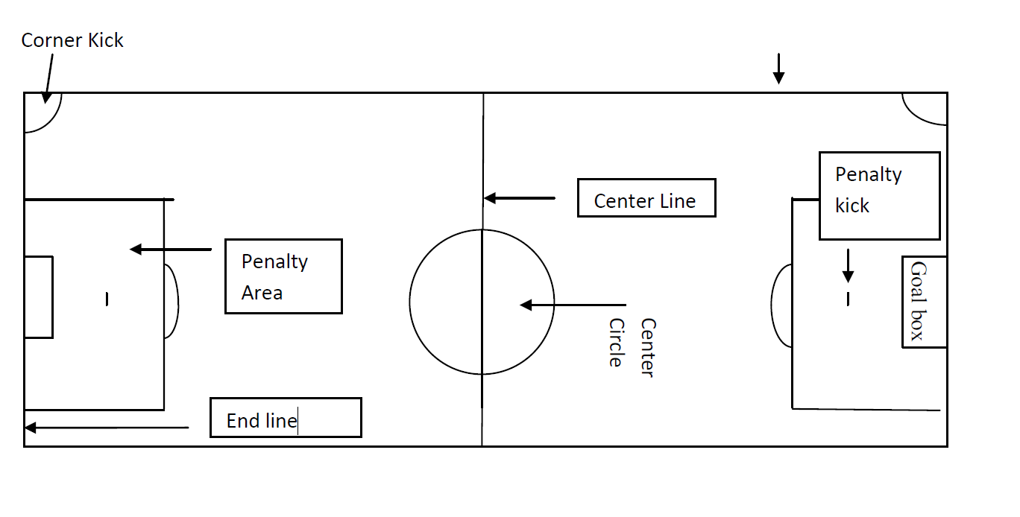
Penalty Arc
Side Line
Forwards (strikers): They are the offensive players responsible for scoring goals.
Midfielders: They are usually your most technical players. Their strengths are ball control and probably your best condition athletes. They position themselves in the middle of your alignment.
Fullbacks (defense): Defensive players who guard the opposing team’s forwards. One player can be a sweeper, roving behind the others watching for players who enter his territory.
Goalkeeper: The only player allowed to use his hands, to prevent opponents from scoring goals. Goalkeepers must wear a different color than his/her team colors to distinguish themselves from the other players.

