Intramural Permission Form
We are excited to announce that the intramural program is back again this year at Arbor Park Middle School. Intramurals will run from November-May at least 1-2xs per week. It is your choice to attend any of the dates that you would like to participate. Intramurals will run from 2:30pm until 3:30pm. Participants are expected to be picked up promptly within 10 minutes of the scheduled intramural end time. If participants are picked up late consistently, they are subject to being dismissed from our intramural program. There is a participation fee of $20.
A t-shirt will be provided to your child for participation.
Requirements to participate:
- You must be passing all your academic classes with a C or higher.
- You cannot receive a referral or an after-school detention. (If either is received by the student the student will not be allowed to participate for 2 intramural sessions)

For Soccer:
Plastic cleats are allowed. NO METAL CLEATS. You may also wear shin guards if you have them.
All other Activities:
Proper athletic attire is to be worn.
Gym shoes must be worn for all activities.

PLEASE RETURN THE SECOND PAGE AND YOUR $20
PARTICIPATION FEE TO MS. ZIEMBA
NO LATER THAN November 26th, 2018.

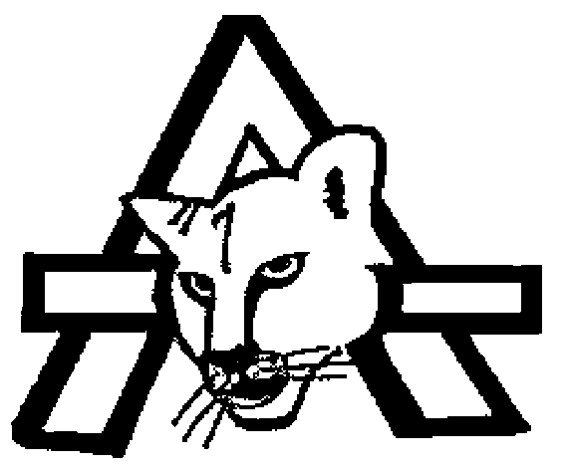 | ARBOR PARK MIDDLE SCHOOL  DISTRICT 145 ·17303 CENTRAL AVENUE, OAK FOREST, IL 60452-4920 ·(708) 687-5330 ·FAX (708) 535-4527  DAVID EVANS, Principal Dr. ANDREA SALA, Superintendent  CAMILLE HOGAN, Principal BRIAN K. O’KEEFFE, Asst. Superintendent of Finance

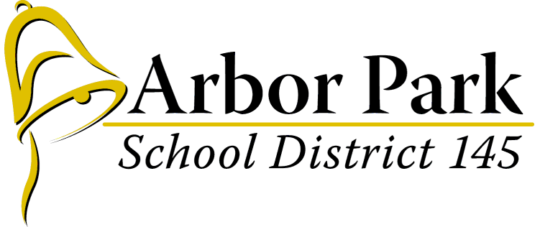
INTRAMURAL / PARENT PERMISSION FORM
The written permission of a student's parent/guardian is required for participation in intramurals. In addition, Arbor Park School District #145 requires parents to assume financial responsibility for all medical and hospital bills incurred as a result of an accidental injury their child sustains while involved in the program. Intramurals may involve some risk of physical injury to the child and parents should be aware of these risks before granting a child permission to participate.
I, _____________________________ (Parent/Guardian Name), grant my child permission to participate in intramurals at Arbor Park Middle School.

I certify that my child has no known medical or physical condition that might make participation in intramurals detrimental or hazardous to his/her health with the possible exception of: (please list and describe)
_______________________________________________________________________________________________________

I also grant permission for school officials to obtain necessary medical treatment for my child in an emergency when I cannot be contacted. I understand that reasonable efforts will be made to contact me prior to treatment.

Student’s Name (Please Print) Grade

Parent’s Signature Date

Please list at least two emergency contacts that can be reached in case of an emergency:
1) Name:______________________________ Phone Number:____________________ Relationship:_________________
2) Name:______________________________ Phone Number:____________________ Relationship:_________________

A t-shirt will be provided as part of your participation fee. Please indicate what size t-shirt you would like.
YM________YL_________ AS___________ AM___________ AL___________ AXL_____________

